Greetings to all stakeholders,

Today, Tuesday February the 16th, Lars Busch and I, Harvey Busch propose that Busch Harland, Incorporated undergoes a name change. The name that we’ve decided to propose is Fenwell Capital Partners. A name that is familiar to the area and street where our firm is currently headquartered in and will be for a long time. The motive for this name change is to create new beginnings. ‘Fenwell’ in view of the fact that it has welcomed us with open arms, offering a space to operate and do what we love the most. ‘Capital Partners’ because we value all of our partners and investors who are and will be part of our history and future.

Please note that there will be no change in management and in the range of products/services we offer. Nevertheless, the name change shall not impact our ongoing cooperation and agreed terms. Our scope and trajectory will remain intact, to maintain our rich history of success and innovation.

Busch Harland, Incorporated name change to Fenwell Capital Partners, LLP. will come into effect on 02/16/2021.

Stakeholders Signatures:
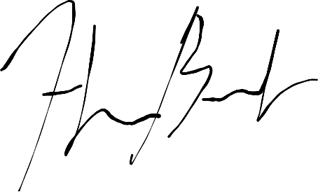
__________________________
Harvey Busch (GP)
Chairman & Chief Executive Officer
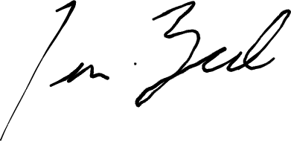
__________________________
Lars Busch (GP)
Non-Executive Director
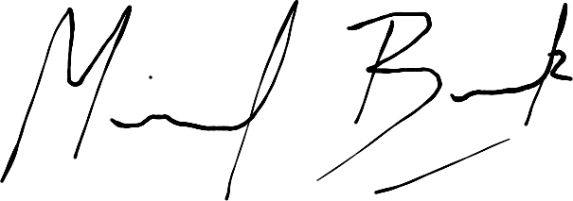
__________________________
Michael Beck (GP)
Vice-Chairman & Chief Operating Officer
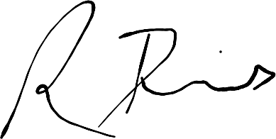
__________________________
Richard Davis (GP)
Chief Administrative Officer

